REFERRAL FORM
*YOU MUST BRING THIS SLIP WITH YOU*

Please call 91 9216023185 to book your appointment

Patient’s Name: Age /Gender: Date:

3D Cone Beam Computed Tomography (CBCT)
FIELD OF VIEW (Tick The Box Of Interest)

Single Site ENDO (4cm x 5cm)
Single Jaw (7X7; 8 X8)
Both Jaws (14 X 8)
Full Skull /Face (14 X 14)

Double Scan Protocol - Open & Closed Mouth - TMJ

Reason for Scan:
- Implant(s) / Graft
- Guided Surgery
- Orthodontic
- Sinus Evaluation/ Airway Analysis
- Endodontic
- TMJ
- Post Operative
- Bone Pathology

Dr. Name: Date:
Dr. Signature:
Contact no: Dr. Email Address:

IMPLANT PLANNING INFORMATION:

Please circle Regions of Interest (ROI)

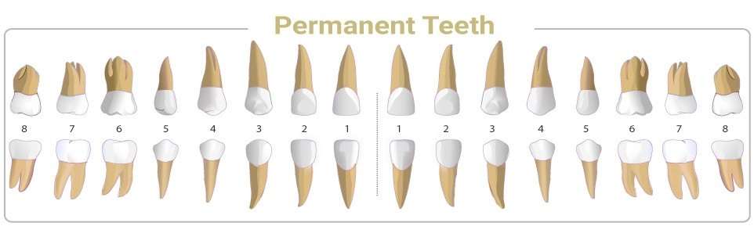

Implant Treatment Planning:

Details For Implant Simulation:

Special instructions / Relevant clinical history:

Dr. Name: Date:
Dr. Signature:
Contact no: Dr. Email Address:

2D RADIOGRAPHY:
(Tick The Box Of Interest)
- OPG
  - STANDARD
  - ORTHOGONAL

- PARANASAL SINUS VIEW

- LATERAL JAW

- LATERAL CERVICAL

- FRONTAL VIEW

- SUBMENTOVERTEX

- CARPAL INDEX

- TMJ VIEWS -OPEN & CLOSED MOUTH

Dr. Name: Date:
Dr. Signature:
Contact no: Dr. Email Address:

